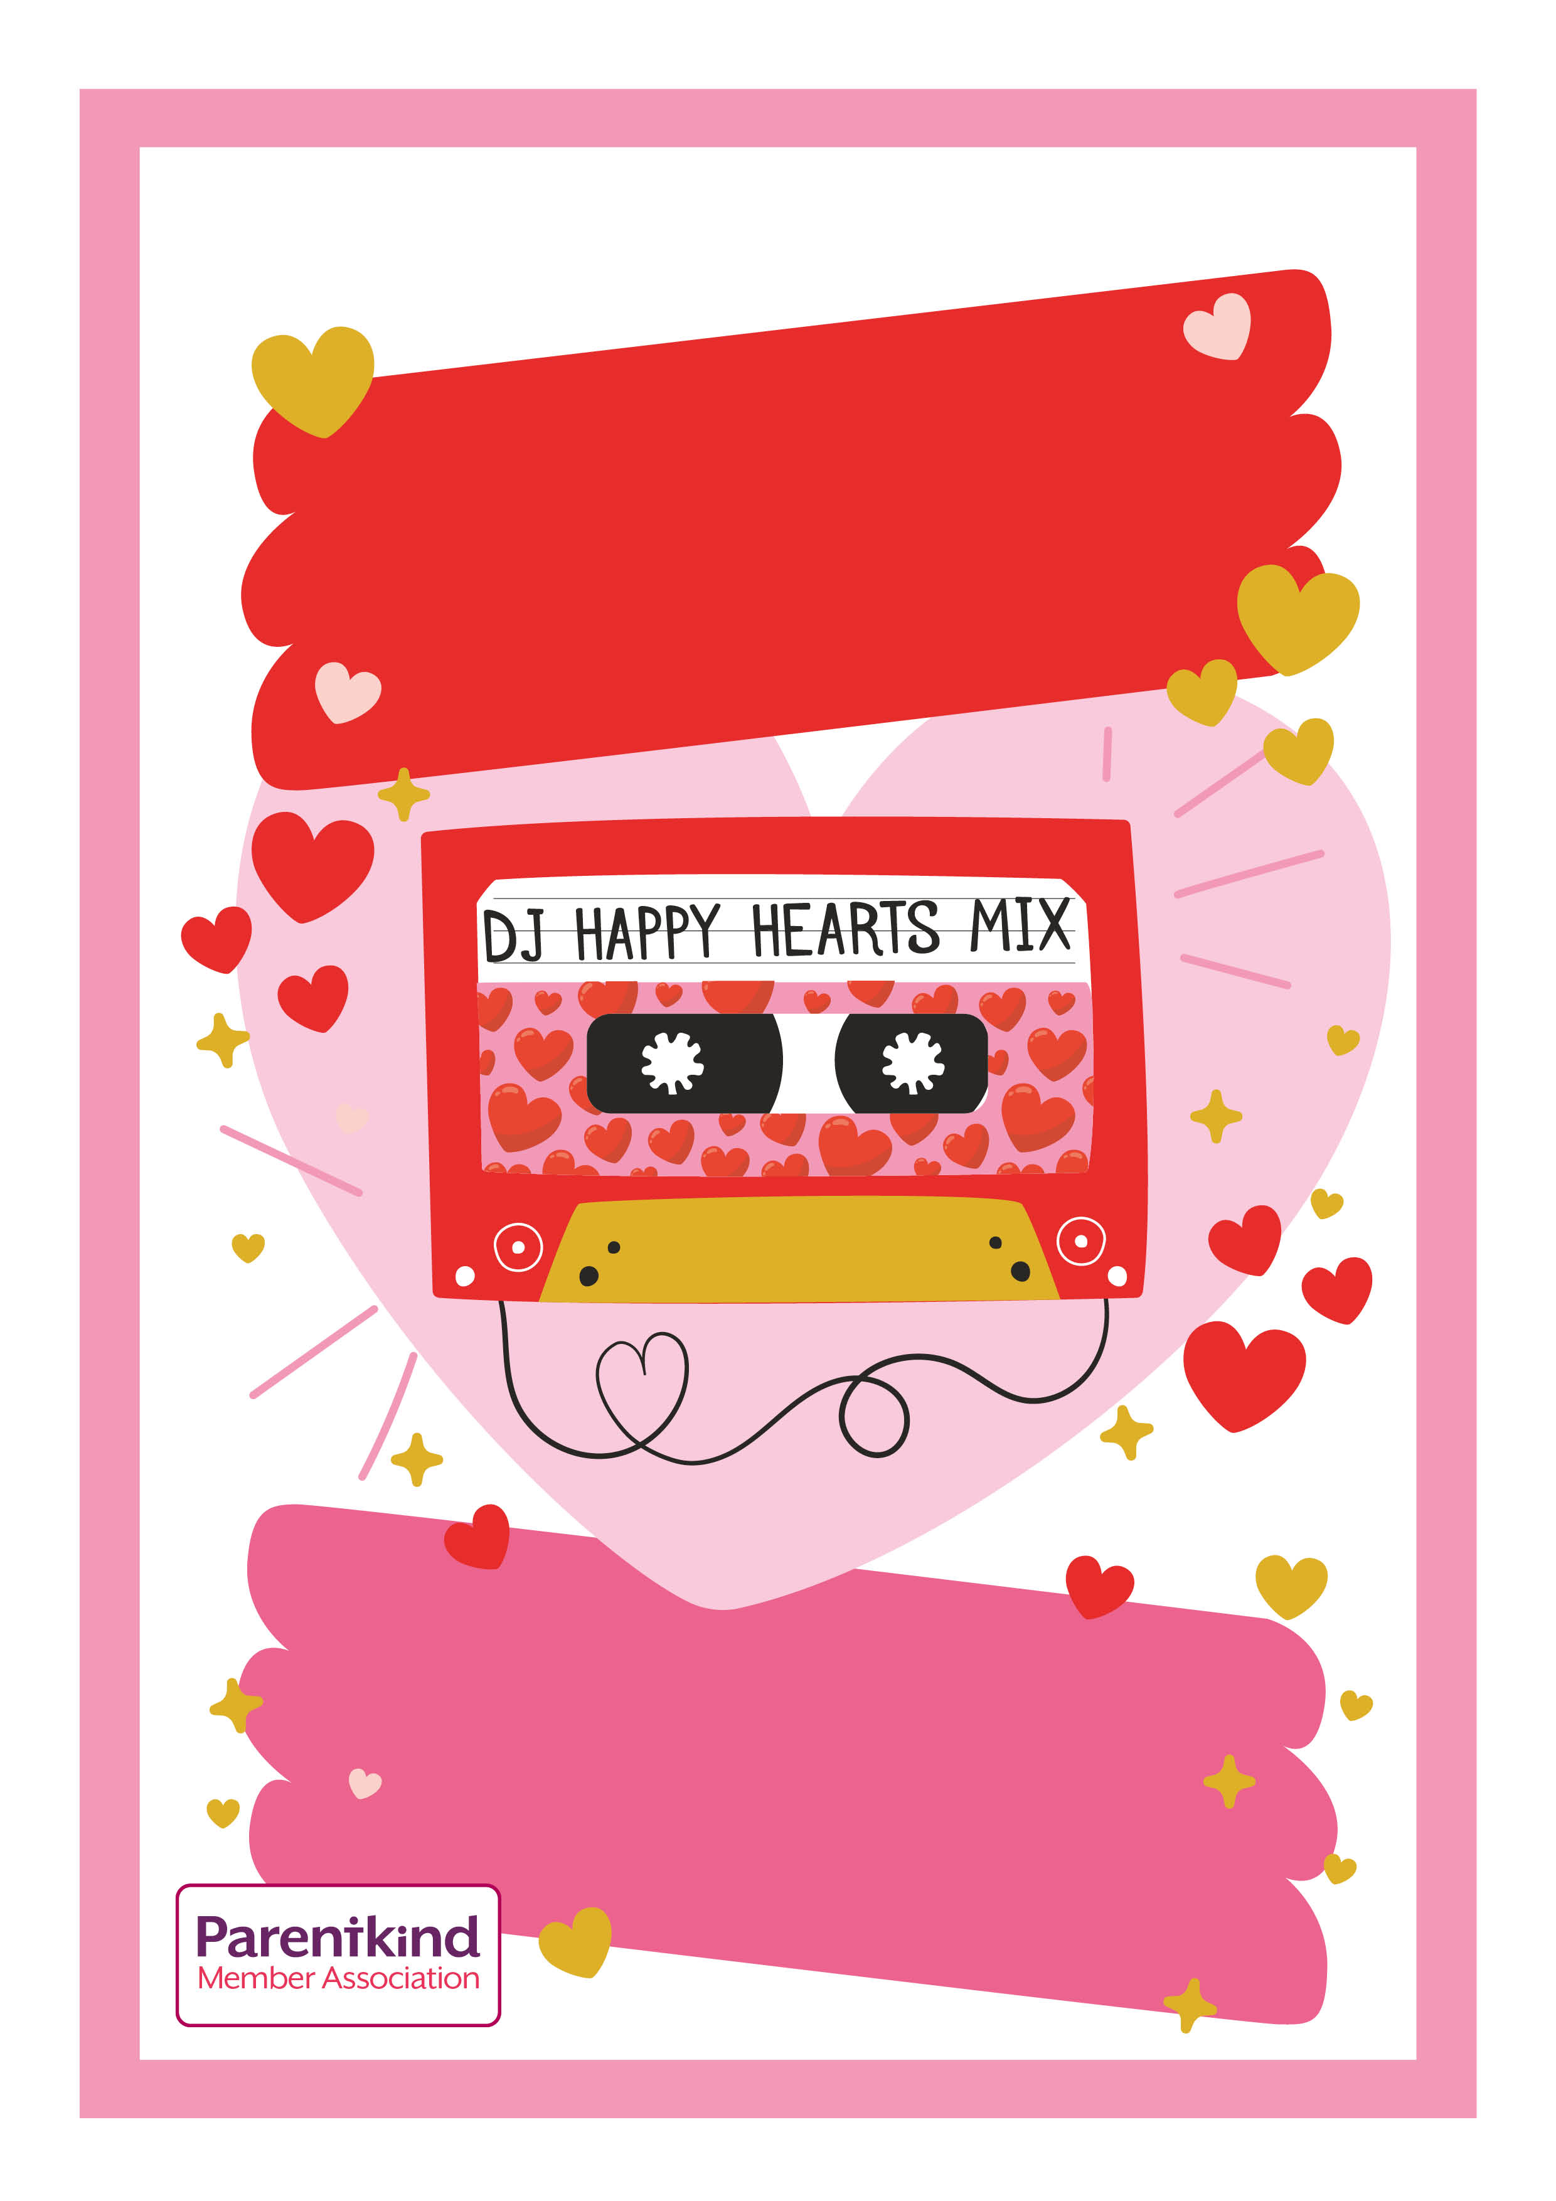

Tickets £3 including hotdog, crisps and juice. On sale via SIMS 24th January -10th February. Please see accompanying

letter (via eschools) for more information

Wednesday 12th February 2020

3.30pm -5pm

Friends of Rowlands Gill Primary School

Valentine’s

Disco