The Bronze Age – Comprehension for Y3 - Completed by 23.10.20

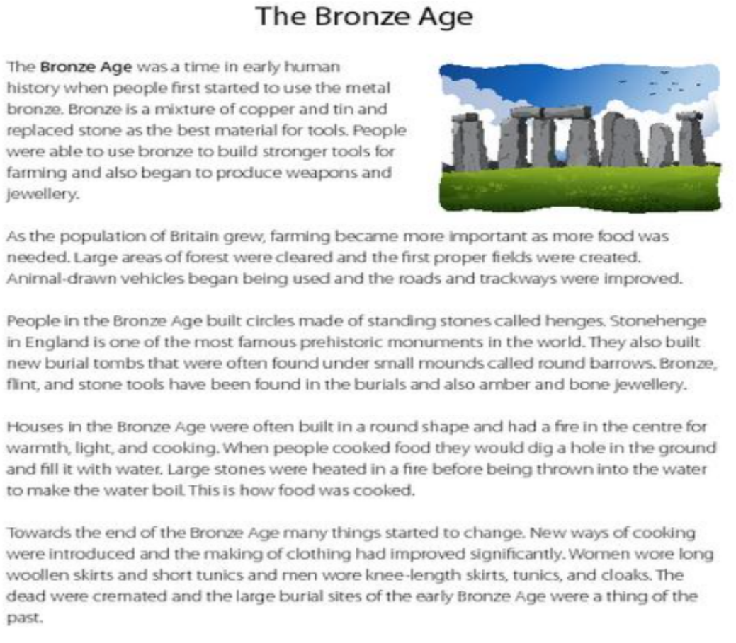

Questions: (please answer in full sentences. Use capital letters and full stops)

1. How did ancient people make the bronze metal?
2. Why was Bronze so useful to British people then?
3. Why was farming such a good idea?
4. What did Bronze Age people do to the countryside to farm it?
5. What kinds of things were found in Barrows?
6. What shape were Bronze Age houses?
7. List two changes that happened at the end of the Bronze Age.